Restore RDS DB from snapshot
Task-1
Explore snapshot options (Restore ss , Copy ss , Share ss , Upgrade ss ,export to Amazone S3)
Task-2
Create RDS primary ,upgrade records ,create replica from primary and test sync write process where data replication or not.
Make some changes to primary DB .
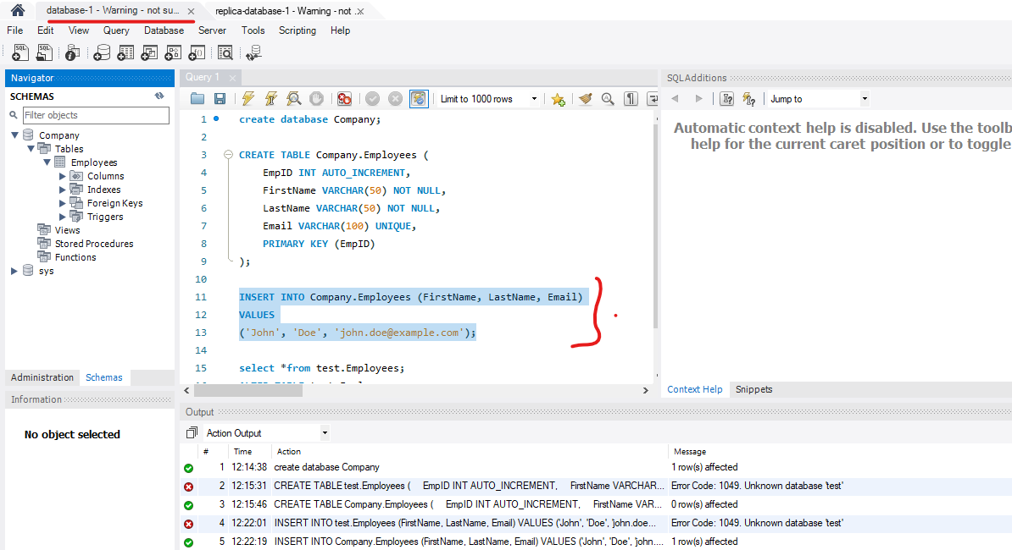
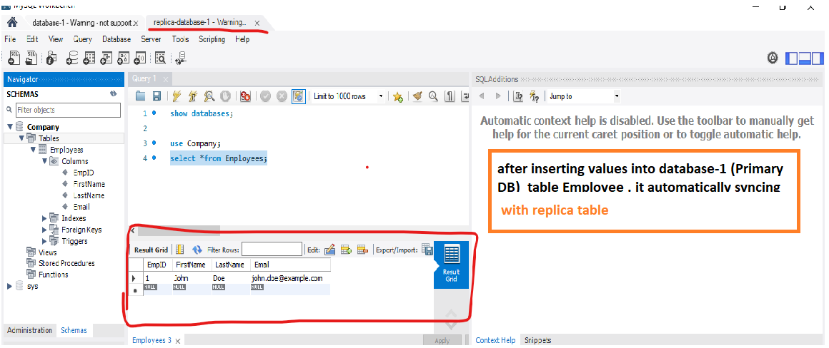

Task-3
Try to write the data into read replica (create db, table ,insert) .
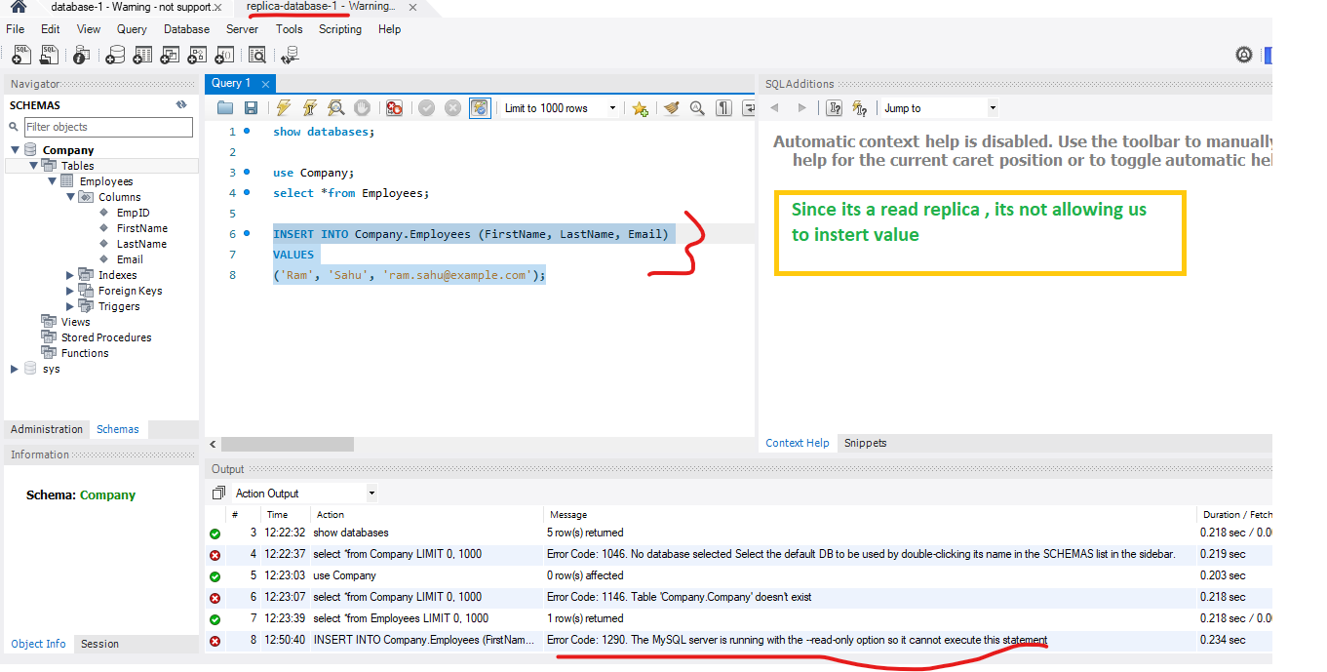
Task-4
Delete master and try again task -3(inserting values into replica database).
Delete master DB
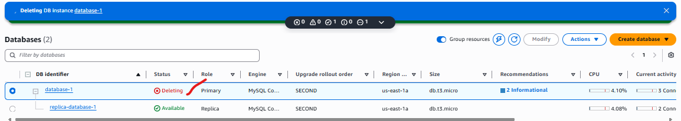

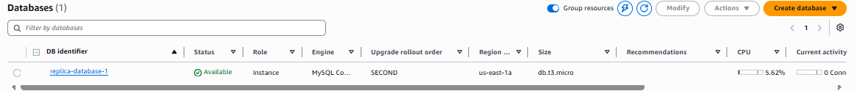
Try writing/insert to read replica
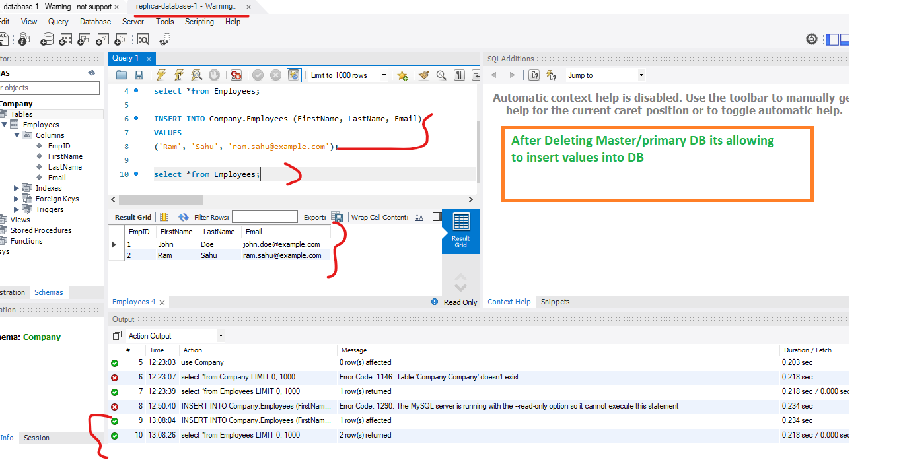
After delete primary DB ,reader replica act as stand alone DB not master
Task-5
Understand the difference between Standalong DB and Master DB.
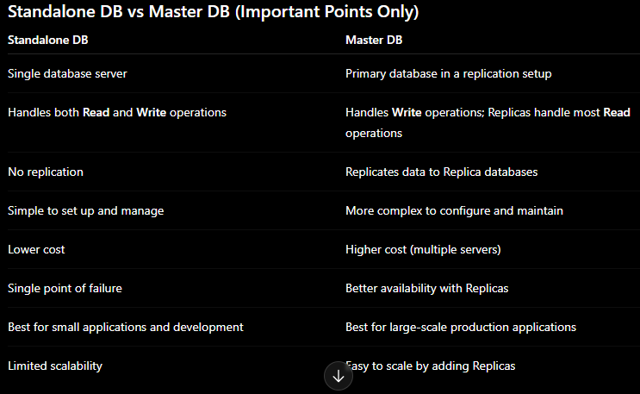

Task – 6
Create a RDS database . add some tables and data into database .take snapshot . delete the primary database . then restore the database from the snapshot .
Create DB
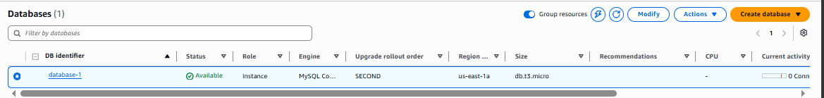
Create replica
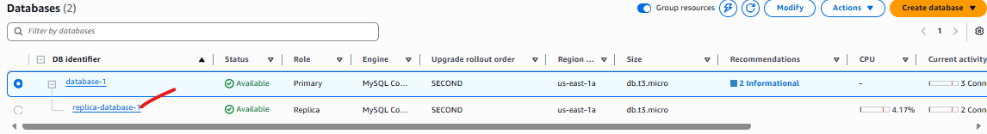
Take a snapshot
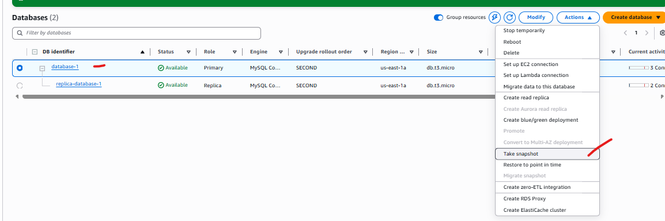
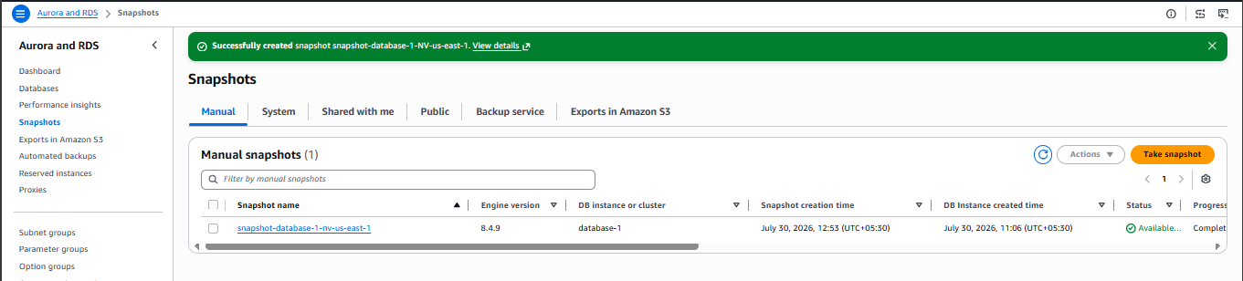

Delete master DB



Now restore DB from snapshot(snapshot-database-1-nv-us-east-1).
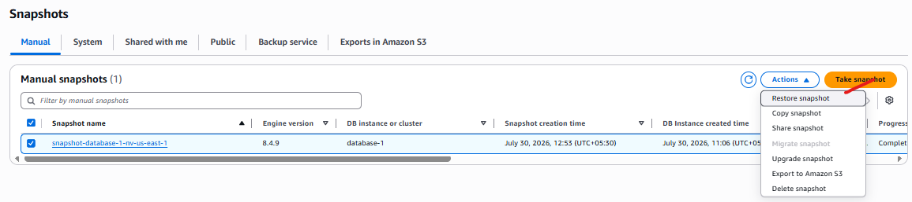
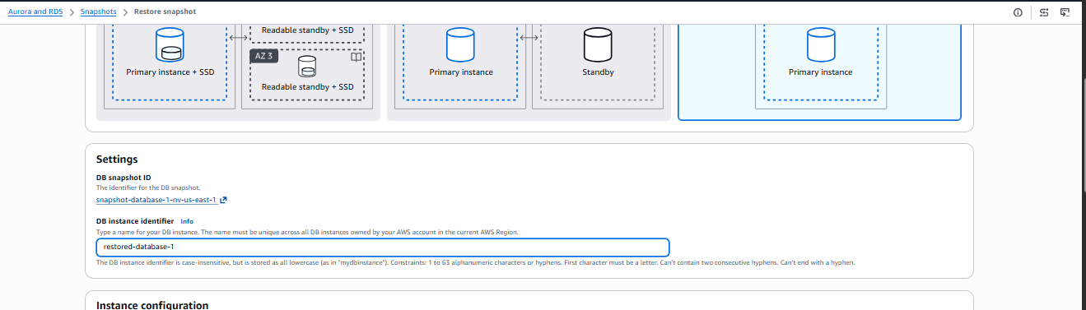
Click restore snapshot , it will take some time .
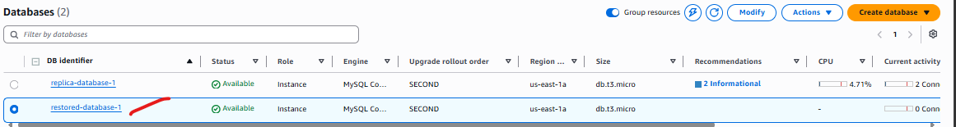

Now connect it with Mysql workbench to check.
Make sure your giving same username/admin/master of server .
Give the restored DB endpoint DNS.
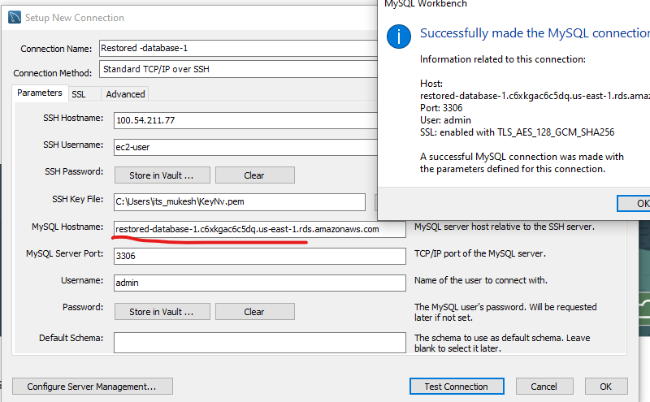
Now connect and check if there is any existing data from database-1.
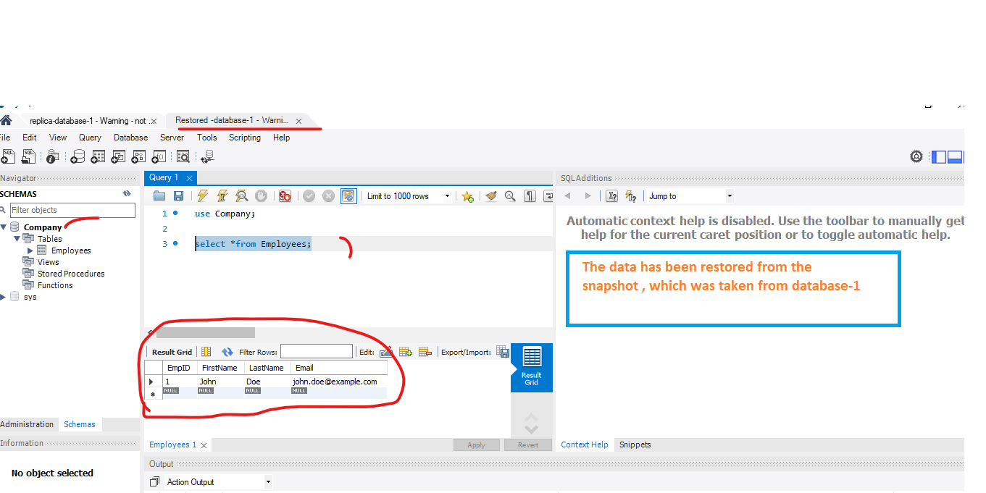
We can see database-1 data is there in the Company.Employees table.

